Álvaro García Zafra
P5 EC

Zumbador

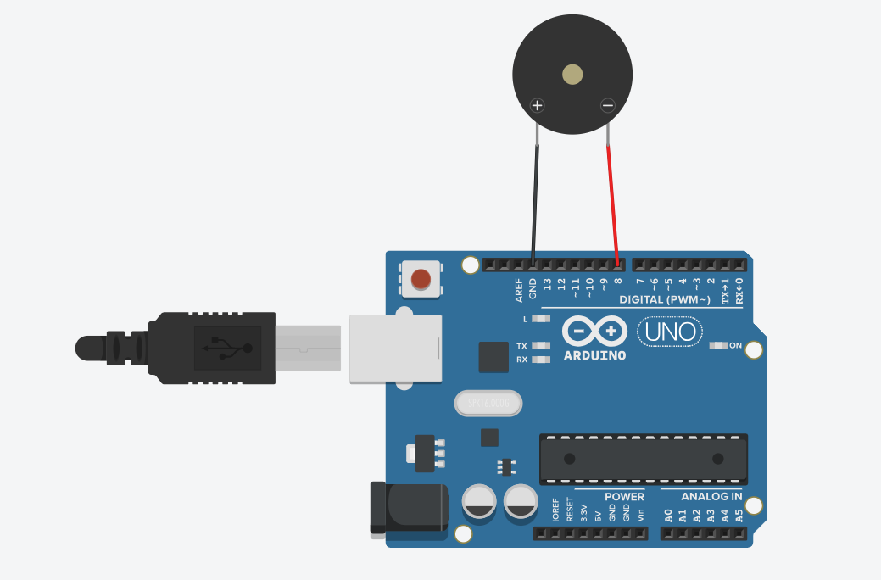
/*************************************************
Public Constants
*************************************************/
#define NOTE_C4 262
#define NOTE_D4 294
#define NOTE_E4 330
#define NOTE_F4 349
#define NOTE_G4 392
#define NOTE_A4 440
#define NOTE_B4 494
#define NOTE_C5 523
#define NOTE_D5 587
#define NOTE_E5 659
#define NOTE_F5 698
#define NOTE_G5 784
#define NOTE_A5 880
#define NOTE_B5 988

// notes in the melody:
int melody[] = {
NOTE_E4, NOTE_G4, NOTE_A4, NOTE_A4, 0,
NOTE_A4, NOTE_B4, NOTE_C5, NOTE_C5, 0,
NOTE_C5, NOTE_D5, NOTE_B4, NOTE_B4, 0,
NOTE_A4, NOTE_G4, NOTE_A4, 0,

NOTE_E4, NOTE_G4, NOTE_A4, NOTE_A4, 0,
NOTE_A4, NOTE_B4, NOTE_C5, NOTE_C5, 0,
NOTE_C5, NOTE_D5, NOTE_B4, NOTE_B4, 0,
NOTE_A4, NOTE_G4, NOTE_A4, 0,

NOTE_E4, NOTE_G4, NOTE_A4, NOTE_A4, 0,
NOTE_A4, NOTE_C5, NOTE_D5, NOTE_D5, 0,
NOTE_D5, NOTE_E5, NOTE_F5, NOTE_F5, 0,
NOTE_E5, NOTE_D5, NOTE_E5, NOTE_A4, 0,

NOTE_A4, NOTE_B4, NOTE_C5, NOTE_C5, 0,
NOTE_D5, NOTE_E5, NOTE_A4, 0,
NOTE_A4, NOTE_C5, NOTE_B4, NOTE_B4, 0,
NOTE_C5, NOTE_A4, NOTE_B4, 0,

NOTE_A4, NOTE_A4,

//Repeat of first part
NOTE_A4, NOTE_B4, NOTE_C5, NOTE_C5, 0,
NOTE_C5, NOTE_D5, NOTE_B4, NOTE_B4, 0,
NOTE_A4, NOTE_G4, NOTE_A4, 0,

NOTE_E4, NOTE_G4, NOTE_A4, NOTE_A4, 0,
NOTE_A4, NOTE_B4, NOTE_C5, NOTE_C5, 0,
NOTE_C5, NOTE_D5, NOTE_B4, NOTE_B4, 0,
NOTE_A4, NOTE_G4, NOTE_A4, 0,

NOTE_E4, NOTE_G4, NOTE_A4, NOTE_A4, 0,
NOTE_A4, NOTE_C5, NOTE_D5, NOTE_D5, 0,
NOTE_D5, NOTE_E5, NOTE_F5, NOTE_F5, 0,
NOTE_E5, NOTE_D5, NOTE_E5, NOTE_A4, 0,

NOTE_A4, NOTE_B4, NOTE_C5, NOTE_C5, 0,
NOTE_D5, NOTE_E5, NOTE_A4, 0,
NOTE_A4, NOTE_C5, NOTE_B4, NOTE_B4, 0,
NOTE_C5, NOTE_A4, NOTE_B4, 0,

//End of Repeat

NOTE_E5, 0, 0, NOTE_F5, 0, 0,
NOTE_E5, NOTE_E5, 0, NOTE_G5, 0, NOTE_E5, NOTE_D5, 0, 0,
NOTE_D5, 0, 0, NOTE_C5, 0, 0,
NOTE_B4, NOTE_C5, 0, NOTE_B4, 0, NOTE_A4,

NOTE_E5, 0, 0, NOTE_F5, 0, 0,
NOTE_E5, NOTE_E5, 0, NOTE_G5, 0, NOTE_E5, NOTE_D5, 0, 0,
NOTE_D5, 0, 0, NOTE_C5, 0, 0,
NOTE_B4, NOTE_C5, 0, NOTE_B4, 0, NOTE_A4};

int duration = 500; // 500 miliseconds

void setup() {
}

void loop() {
int songLength = sizeof(melody) / sizeof(melody[0]);
for (int thisNote = 0; thisNote < songLength; thisNote++) {
// pin8 output the voice, every scale is 0.5 sencond
tone(8, melody[thisNote], duration);
// Output the voice after several minutes
delay(125);
}

// restart after two seconds
delay(2000);
}

Theremín sin leds

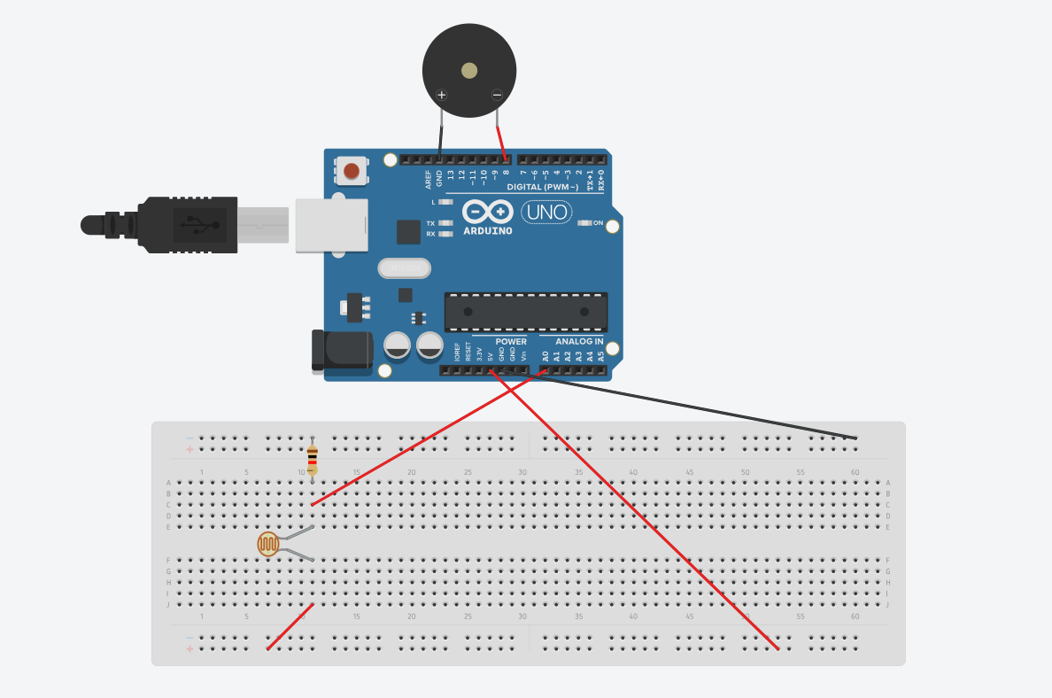

// variable to hold sensor value
int sensorValue;
// variable to calibrate low value
int sensorLow = 1023;
// variable to calibrate high value
int sensorHigh = 0;
// LED pin
const int ledPin = 13;

void setup() {
// Make the LED pin an output and turn it on
Serial.begin(9600);
pinMode(ledPin, OUTPUT);
digitalWrite(ledPin, HIGH);
// calibrate for the first five seconds after program runs
while (millis() < 5000) {
// record the maximum sensor value
sensorValue = analogRead(A0);
if (sensorValue > sensorHigh) {
sensorHigh = sensorValue;
}
// record the minimum sensor value
if (sensorValue < sensorLow) {
sensorLow = sensorValue;
}
}
// turn the LED off, signaling the end of the calibration period
digitalWrite(ledPin, LOW);
}
void loop() {
//read the input from A0 and store it in a variable
sensorValue = analogRead(A0);
Serial.print("Value: ");
Serial.print(sensorValue);
Serial.print(" | Low: ");
Serial.print(sensorLow);
Serial.print(" | High: ");
Serial.println(sensorHigh);
// map the sensor values to a wide range of pitches
int pitch = map(sensorValue, sensorLow, sensorHigh, 50, 4000);
// play the tone for 20 ms on pin 8
tone(8, pitch, 20);
// wait for a moment
delay(10);
}

Theremín con leds

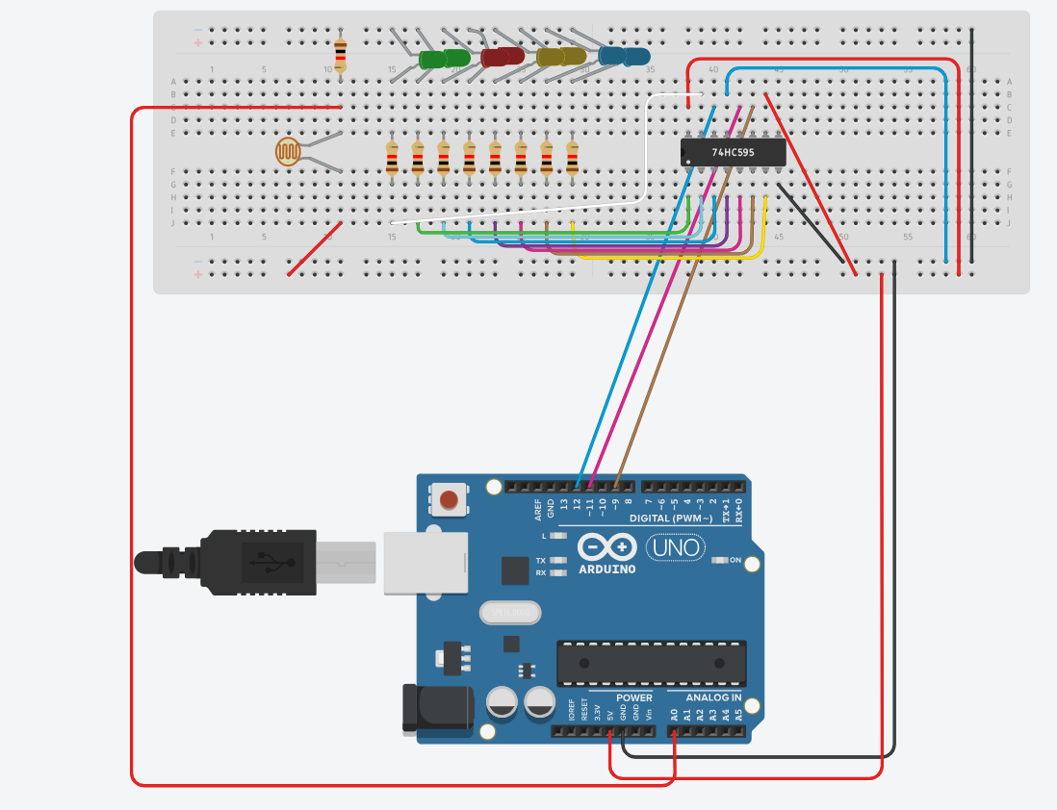
Tuve que cambiar las resistencias de 220ohmios por las de 1kohmio, ya que daba error
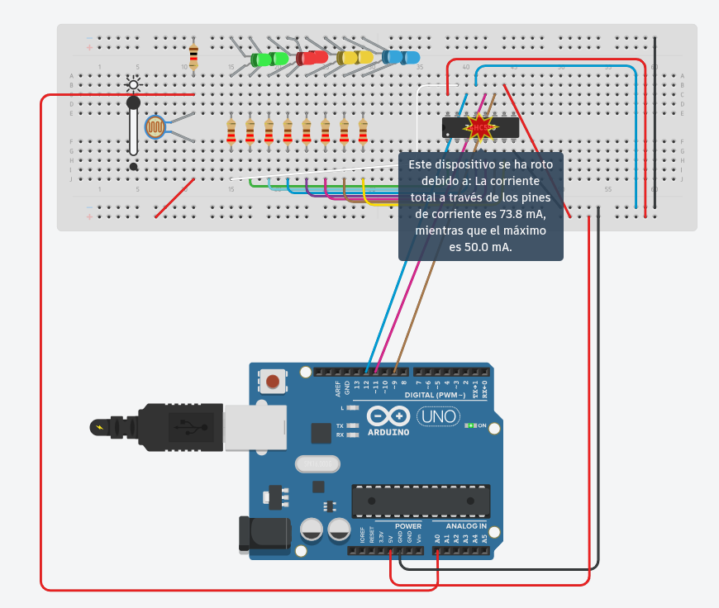

int lightPin = 0;
int latchPin = 11;
int clockPin = 9;
int dataPin = 12;

int leds = 0;

void setup()
{
pinMode(latchPin, OUTPUT);
pinMode(dataPin, OUTPUT);
pinMode(clockPin, OUTPUT);
}
void updateShiftRegister()
{
digitalWrite(latchPin, LOW);
shiftOut(dataPin, clockPin, LSBFIRST, leds);
digitalWrite(latchPin, HIGH);
}
void loop()
{
int reading = analogRead(lightPin);
int numLEDSLit = reading / 57; //1023 / 9 / 2
if (numLEDSLit > 8) numLEDSLit = 8;
leds = 0; // no LEDs lit to start
for (int i = 0; i < numLEDSLit; i++)
{
leds = leds + (1 << i);
}
updateShiftRegister();
}

